**Project Design Phase-I**

**Solution Architecture**

|  |  |
| --- | --- |
| Date | 8 october 2022 |
| Team ID | PNT2022TMID13948 |
| Project Name | Gas leakage monitoring and alerting system |
| Maximum Marks | 4 Marks |

**Solution Architecture:**

* The presence of hazardous LPG gas leakage we can set an alarm unit which is used to vibrate an alarm buzzer.
* Buzzer gives an audible sign of the presence of LPG volume.
* The sensors are widely used to detect essence of propane, iso-butane, LPG and even smoke.
* Arduino UNO is used in the project this Arduino UNO turns on the LCD and buzzer.
* Global Journal of Engineering and Technology Advances
* It even turns on the GSM modem after that, it continues to send messages SMS to mobile number specifically mentioned in the program of the source code for alerting danger to the people.

**Example - Solution Architecture Diagram:**

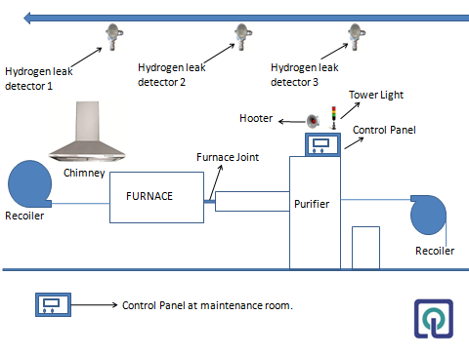

Figure 1: Architecture and data flow of the voice patient diary sample application

**Reference: https://www.researchgate.net/publication/347495607_Gas_leakage_detection_and_alerting_system_using_Arduino_Uno**